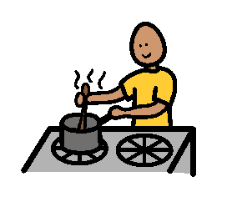
Class 3 is cooking today.
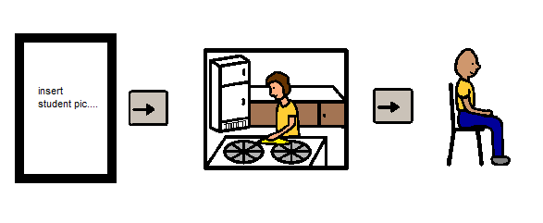
Eddy will go into the kitchen
and sit down quietly.

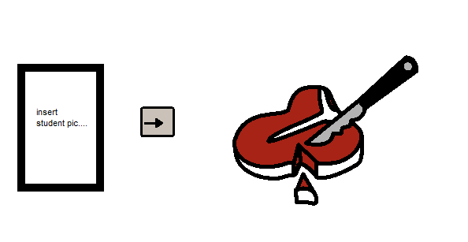
Eddy will help to prepare
the food for cooking.
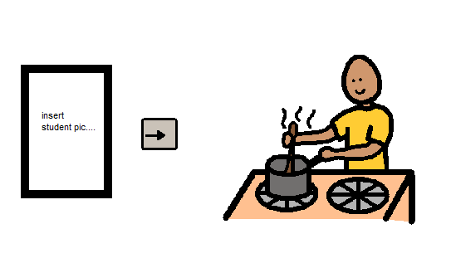
Eddy will help to cook the food.

Eddy will be happy in the kitchen.

Eddy will smile in the kitchen.
Eddy will be quiet in the kitchen.

